Cryptographic approach for security enhancement of
Data using blockchian in enterprises

Rami Reddy Sai Sumanth
SENSE
B. Tech, ECE
Vellore Institute of Technology
saisumanthramiredyy@gmail.com

Bhargav Reddy B
SENSE
B. Tech , ECE
Vellore Institute of Technology
battureddy2002@gmail.com

Sujatha R
Associate Professor
Departement of Embedded Technology
Vellore Institute of Technology
Sujatha.r@vit.ac.in
Atluri Varun Chowdhary
SENSE
B. Tech , ECE
Vellore Institute of Technology
Varunchowdary2730@gmail.com

Abstract— Data security is a concern for many organizations, and various algorithms are used to achieve confidentiality, integrity, and availability. However, centralized cloud storage doesn't always provide these features. So, to improve data security and storage techniques, decentralized cloud storage is used in conjunction with cryptographic technology. This effectively protects data from tampering or deletion. Then Data is encrypted and then converted into an unreadable form and this unreadable format data was used to transfer in the form of blocks in and at the end user the encrypted message used to Decrypted and lead to get the original message back. This method reduces the chances of data being altered. SHA-512 hashing algorithm is used to create the hash values for the encrypted data main creation of hash values is to format encrypted data into the block format and hashing algorithm are implemented in many aspects of security, where the data security is required. For example, it is used to create message digests, verify passwords, and create digital certificates. By combining all methods like AES, hashing algorithm, cryptographic implementation and block chain data becomes more credible and secure. The implementation of the block chain lead to add the additional security for the encrypted data so no one can easy able to tamper the data. Hence, the security of the data will improve with the use of various hashing techniques.
Keywords— Blockchain, Decentralization, CIA Properties, AES- Algorithm, Cryptography, Encryption, Decryption, Unified Modeling Language (UML)

Introduction (Heading 1)
Cryptography is a distributed database that is used to store information securely in digital format. Cryptography is helpful in maintaining a secure and decentralized record of transactions, and it is also known for its role in digital systems, such as Bitcoin. The main difference between the cryptography and database was how data arranged. Cryptography used to collect the data together from group, and that collected data was stored in form block, which hold the information of group. Here blocks used to create storage capacity and it used to have certain capacity once it filled it used to link to another block, is already filled, which form a chain of data. When new information added it lead to have new block, freshly added block will added to the chain of block once it filled. A shared, unchangeable ledger created by cryptography makes it easier to track data information and record transactions in a corporate network. An asset may be physical or intangible.
Everything of value may be tracked and traded via a cryptographic network, reducing risk and costs for all parties. Blockchain are used to implemented for all the information that are essential to businesses. The data it blokcchian contain accurate and faster it’s recived. Cryptographic networks are ideal for delivering information because they provide immediate, shared, and entire information is stored in the ledger that can only accessed by authorized person. A cryptographic network can track orders, payments, accounts, production, and much more because the share of any data file, can see all the detail of transaction for end to end which gives the greater confidence.
We provide an improved system that generates results that are quite near to the ideal ones. Our addition work is effective for both the bursting of architecture-based service compositions as well as behavior-based compositions of behaviours.

literature survey
LanxiangChen QingxiaoFu etal[2] have proposed how data become more and more attention because of the cloud storage, integrity verification for outsourcing of data. The vast bulk of current research relies on a certain third-party auditor (TPA) or fixed TPAs used to check the accuracy of the data in the outsourced, making them vulnerable to DoS and collusion attacks because the TPA cannot be fully trusted. A verified random function (VRF) is used in the designed cryptographic consensus process to chooses the third party committee that will carry out the contract verification. The basic premise is that a fixed percentage of malicious nodes may be tolerated and that individual nodes cannot be targeted in advance.

In cloud environment to secure the data the proxy re-encryption approach implemented by Kwame Opuni-Boachie Obour Agyekum etal [5] by using the identity – based encryption where the encrypted data was outsources by the OWNER to the cloud storage, again to access the data from the cloud the building of a proxy re-encryption will allow authorised individuals. Due to the limited resources of Internet of Things devices, an edge device serves as a proxy server to perform demanding calculations. Cached material over the proxy was send efficiently by the help of the information centric network, enhanced service quality and make appropriate use of network bandwidth.

By implementing the concept of the blockchain Songwei Fan and Yue Chen[4] have hold offensive data such as attack scripts, dark network service addresses, and pornographic material. Blockchain also confront a number of issues, including the inability to reverse incorrect transactions and eliminate fraudulent transactions, as well as the lack of an editable cryptographic system based on Hash key sharing. The general structure of the altered blockchain structure not affected because of the chameleon hash properties, The Shamir key sharing mechanism can make sure that every modification represents the nodes' collective.
.
Partha Sarathi Chakraborty etal[8] by using the BSMFS, a blcokchain-assisted Fuzzy search over encrypted data. The well-known threats search, access, and volume pattern leakage cannot cause information to escape from the BSMFS. To provide the nice interaction between the data user and the cloud the smart contact is developed by the ethereum Blcokchain, and for the effective search in the smart contact developed by the blockchain bloom filter is added. The viability of BSMFS is examined through experimental study on Ethereum test networks.

Using a system based on public and private blockchains called Privacy-Preserving Searchable Encryption (PPSE),
Ruizhong Du etal[9] created private blockchain with the help of encrypted index. while transferring relevant encrypted data to a public blockchain approach might minimise the storage requirements for the blockchains, which lead to improve the effectiveness in security of data and transaction. To ensure data privacy and the accuracy of access control verification, it also features smart contracts that establish a secondary verification access control mechanism and limit data users' access to the private blockchain through authorisation.

Justin S. Gazsi etal[11] have implemented using centralized both data storage and data exchange are essential. Because users are required to trust a single central authority and its decision-making for the whole system, existing centralised data exchange and access methods offer less transparency and traceability. Interplanetary File System (IPFS)-encrypted files are references to the files in the Cryptography. Users may store, access, and share data as well as manage through cryptography using VAULT, which is ideal for applications involving cooperation from many permissioned parties. This paper mainly about that user selection in quorum is fair, and scalable of the VAULT protocol.

By the combination of the cloud with the cryptography technology S. Uthayashangar etal[12] have implemented how data file is stored securely. In this single file is divided and stored in blocks utilising the file manipulation and Advanced Encryption Standard (AES) algorithms, where blockchain is widely regarded as the safest technology. To implement the smart contact the high level of contract oriented language, solidity is used. In blockchain and cloud manipulations was build in this system architecture of the project which make to have the more security to the data because of this mechanism.

Hyperledger Fabric is build with the help of blockchain and using this concept Hanan EL Bakkali etal[] Using the Inter Planetary File System, health data was incorporated (IPFS), with high resilient and scalable distribution of data storage. By using smart contact and also compared with the other ideas, they have proposed the idea where the For both medical IoT data and electronic health records, this study included data access control and data usage auditing techniques (EHRs). Furthermore, by implementing a cutting-edge Privacy Agreement Management system, healthcare stakeholders may held accountable. The results of the proposed SmartMedChain's experiments and security analyses demonstrate its viability and effectiveness in s-healthcare contexts.

Yang Xu; Ju Ren etal[15] by using the blockchain and a smart contact for network storage service, the decentralized arbitable of data auditing system was designed. For the purpose of notarizing integrity metadata of outsourced data that is accepted by the user and servers on blockchian, here the blockchain network used to achieve the non-repudiation verification by using the self-recording channel. With the support of the hash function technique, defending against dishonest provers and verification, the data have the secured protocol it used to transfer from end to end users.

R Sujatha , M Ramakrishnan etal [16] In this to fulfill the signcryptography they have implemented the public key encryption and digital signature, all this is a kind of cryptographic primitive. The same public key is used for the security purpose the cryptographic primitive was implemented in efficiently for the large messages and the same key also suitable for the very small message. In this practical way is provided by the hybrid encryption KEM and DEM techniques was developed based in the hybrid signryption, to encapsulate the symmetric key the KEM and KDF techniques are implemented.

Sujatha. R and Ramakrishnana.M [18] proposed the new hybrid algorithm is used to address the issues with message confidentiality and authenticity with the help of elliptical curve cryptography. MANETs are vulnerable to attack due to their open environment, where all nodes participate in data transfer, and high level cryptography was implemented to improve the performance of MANETs. Therefore, this helps to have the both digital signature and encryption schemes in a single step.

Architecture and Methodology
There are different types of architectures that can protect data using different technologies. In this model, we have used Cryptography includes the AES algorithm and SHA-512 to protect and secure the data. The main idea is to protect the data in the form of blocks with different algorithms, which helps to keep the data secure without any chance of it being stolen, disclosed, or tampered with. We use different algorithms, such as AES, to encrypt and decrypt the data. SHA-512 to create the hash values for the encrypted data, and by using the hash values it used to interlinking the blocks created for the encrypted data and cryptographic algorithm to convert the encrypted data into a block format
. 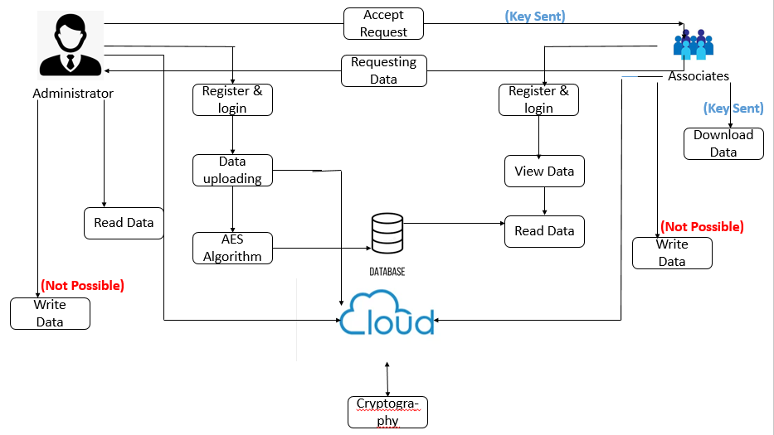
Fig 1. Proposed architecture for data security using cryptography.
Fig 1 shows how data can be securely shared between administrator and a few associates. If the administrator requires to share data with associates in a secure way, they first need to register and login, and then upload the data they want to communicate. Once data file uploaded, the data is encrypted using an AES algorithm, and stored in a local database. The same file is also stored in the P-cloud. On the associate side Fig 3, they can view and read the file, and if they want it, they can send a request to the administrator. Once the file request was sent by the associates then administrator Fig 2 used to accept the file request then uses the SHA-512 algorithm to decrypt the data and stores it in a database. If the request is from an unauthorized person, the administrator can decline it. If the administrator accepts the request, the data is converted into an encrypted format, and hash-values are generated for that encrypted data. The blockchain is then used to divide the encrypted data into three block format, and for each block, the hash-value is created. The hash-values are used to connect the blocks together, like previous hash-values with new hash-values, forming a chain of block with more security to the data. So, data is transferred to the end users in the secured format in the form of blocks so the end user can download the secured data file.
Fig 2 and Fig 3 indicates the Module representation of the Architecture.
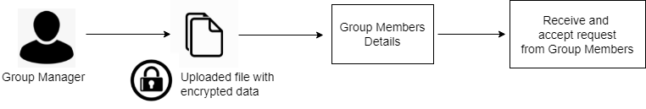
Fig 2. Administrator transmit and authorizing Request
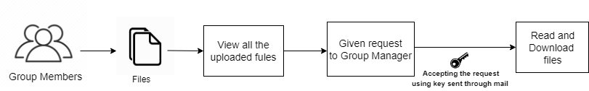
Fig 3. Admittance and download by Associates

AES-Algorithm
There's a pretty common symmetric encryption algorithm that is actually faster than Triple DES, and it's more widespread nowadays. AES is the name of the algorithm, and it's used for encrypting data. It's a bit more efficient than Triple DES, and it's faster too.
The following are AES’s characteristics:

- It generates symmetric key for each symmetric block cipher
- It has different key sizes like 128/1922/256 – bit key (but preferable is 128) ,
- Compare to Triple DES it has grate storage and faster
- It was developed using Java and C.

Based on the substitution and permutation network AES algorithm was an iterative cipher text. For the given input it uses to comprises a set of operations that help to replace the given input and provide the specific output (substitutions) and there are other set of operators which are involved in shuffling the bits around (permutations). In this the administrator used to upload the data first to convert the data into the cipher text. As the administrator uploaded the data the AES algorithm Using bytes rather than bits for all of its computations, which means that it treats the 128 bits of an input plaintext into the block form of the 16 bytes. These 16 bytes of information are organised into four columns and four rows for matrices processing. In contrast to DES, the number of rounds in AES varies based on the size of the key. And we are giving the input data in the form of 128-bits in-built the AES used to perform the 10 rounds for 128-bit keys, if the input size was increased then it used to increase the round like 192 – bit key produces 12 round and 256 – bit key produces 12 rounds. Nevertheless, our model's implementation employs a 128-bit input to conduct 10 rounds, and new 128-bit round key was generated in each round, which is calculated from the original AES key and once the encryption was done for all 10 blocks, it joins them together to form a cipher text.

So, once the data is given as input for AES-Algorithm the input data is converted into the encrypted code and AES key also generated by the process of the AES-Algorithm before generating the hash-value then entire text that was uploaded by the Administrator will convert into the encrypted text and that text will be stored in the local database. So, for converting data into encrypted text, we use the AES-Algorithm.

SHA-512 Algorithm
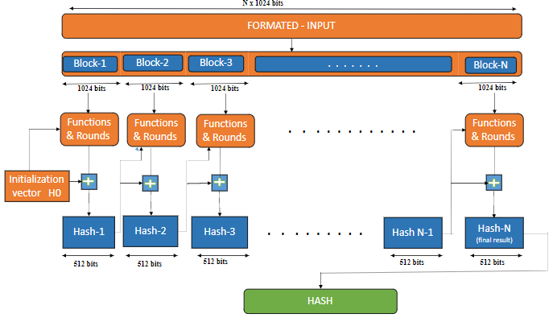

Fig 4. Architecture of SHA-512 algorithm.

SHA-512 is a hashing algorithm that is used to create a hash value for any type of input data. Hash values implemented in a wide variety of real-world applications, including digital certificates, blockchains. and internet security. This SHA-512 hashing algorithm overview includes some fundamental and elementary arithmetic as well as visuals to make it easier to grasp. It belongs to the SHA-2 family of hashing algorithms, which also includes SHA-256. The creation of test cases for unit testing assures that the fundamental programming logic is functioning properly and that programmer inputs produce legal outputs. SHA-512 is the unit testing algorithm used to verify functionality that has been done internally.

Encrypted data produced by the AES-Algorithm will be given as input for SHA-512, which has a length of N x 1024 bits and is divided into 1024-bit blocks. Each block of data was subjected to certain functionality and rounds, which are represented in equations 1 and 2, and with the aid of these two equations, internally we can obtain a fixed hash-value of 512 bits.
For every word of the length 1024 bits, it will undergo the functionality and round.

Functionality
Message divided from 1024-bit to 64-bit block format.

W_{t} = σ₁⁵¹² (W_{t-2} )+ W_{t-7} + σ₀⁵¹² (W_{t-15} ) + W_{t-16} →1

σ₀⁵¹² (x) = ROTR¹ (x) ROTR⁸ (x) SHR⁷ (x)

σ₁⁵¹² (x) = ROTR¹⁹ (x) ROTR⁶¹ (x) SHR⁶ (x)

ROTR^{n}(x) = circular right shift of the 64-bit argument x by
n bits

SHR^{n}(X) = Left shift of the 64-bit argument x by n bits with
padding by zero on the right

+ = addition module 2⁶⁴

By using equation-1 of the mathematical functions the functionality of each new word of 64-bit is generated (i.e., W_{t)} where the word of block 1024 bits was divided into the 64 bits of each block, and it forms 80 blocks. After dividing inside the functionality, the scheduling of messages is done using the mathematical formulae. Each formatted input i.e., encrypted data that are created from the AES algorithm was divided into the 1024 bits of block it created N-number of blocks based on the input data. Ones 1024-bit encrypted block is created then the data is divided into 64-bit messages, which produced an 80-message block. Input text contains 1024 bits, and the first 16 words can be created directly. However, from words 17 to 80, the above equations must be used. Starting with word 17, these equations must be combined with W0, W1, W9, and W14, where W1 combined with sigma0 and W14 combined with sigma1 help create a new word of 64 bits.

Hash generated for each round.

T₁ ₌ h + Ch(e,f,g) + (∑₁⁵¹² e) + W_{t} +K_{t} → 2

Ch(e,f,g) = (e AND f) (NOT e AND g)

(∑₁⁵¹² e) = ROTR¹⁴ (e) ROTR¹⁸ (e) ROTR⁴¹ (e)

ROTR^{n}(x) = circular right shift of the 64-bit argument x by
n bits

T₂ = ∑₀⁵¹² a + Maj (a,b,c) → 3

Maj(a,b,c) = (a AND b) (a AND c) (b AND c)

(∑₀⁵¹² a) = ROTA²⁸(a) ROTA³⁴(a) ROTA³⁹ (a)

The mathematical equations T1- (2) and T2- (3) are present in each round, and each value from that round will serve as the input to the next round. This process must be carried out for 80 rounds in order to create a new hash value for the block of data. At the end of those 80 rounds, a new hash value is created for each, and every block message and that hash value will act as the input to the next block of data and this process continues till the end of the data blocks. At the end of the final data block a new hash value is created to the encrypted data. And for each round it used to form the 80 rounds to form the new hash value Verifying the internal code flow and every decision branch is crucial. After the completion of each individual unit, it is the testing of the application's many software components before integration. It contain the invasive structural test that requires knowledge of its construction. Fundamental testing performed at the component level by unit tests, which have the specific configuration of a system, application, or business process. Unit tests ensure that every separate business process route follows closely to the given criteria and has well-defined inputs and outputs.

In our model, three different hash values are created. If associates want to access a specific file, they must send a request for that file first hash value created. Once the administrator accepts the file that was requested by the associates, a new hash value is generated and finally, for the data file for which associates sent the request, the final hash value is created. So, all this hash values are created based on the data that was divided into block that are represented in Fig 4 and internally all functionalities and Rounds are also implemented using the equations 1 and 2.

Hashing Function

By using a hashing algorithm, data given as input and the output is a message digest with a specified length (512 bits). Before using this output message it need to satisfy some requirements. To generate the hashing value, we use the complex algorithm that converts the arbitrary length to the fixed length so if any one value is changed then the entire hash value will be affected.

It is obvious that various output values will be obtained even with the identical input values since the message digest's length is constant and the amount of the input data might vary. In terms of the implementation process the different data is taken as the input for the SHA-512 algorithm but we used to get the fixed length at the output. If the same data is taken as the input for more than once, we used to get the different hash values for the same data.

In the case of uniform distribution, hash function is such a way for any input data each possible message digit value of the equal length generated.

Fixed Length: Fixed length is mainly explain about each output value should be of the fixed length, there are different sizes of inputs that are passed to the to create the hash value but we the fixed length of output is generated for any input size length.

Collision resistance: Thus, it is impossible to create two different inputs to the hash function that produce the same output (hash digest).

The data uniformly distributed with a fixed length without collision resistance. The three primary characteristics listed above are those implemented when there is creating hash values. When there is data transfer between the administrator and associates, if any of the properties in the generation of the hash-value is failed then it would be quite simple for any third-party individual to capture or modify the data. It is safe to say that, In your proposed model the hash value from SHA-512 algorithm will not be identical collision resistance and fixed length of hash digest.

Block interlinking using Hash-values

Cryptography is the method of developing techniques and algorithms which help to prevent third parties from accessing the data during the communication process. There are several terms that are related to cryptography, and they are encryption, decryption, cipher, and key. The implanting of the hashing function where the hash value of fixed length is generated for the cipher text is created using the AES-Algorithm. The plain text is converted to unique cipher text of a specific length. Unlike encryption the hash function does not require any component like the decryption hash value. And it basically functions with the aid of the plain text that we used to create the hash value, which is linked to other hash values to create a chain of blocks.
In your model, three different hash values are generated with the help of the hash function and those hash values are interlinked to each other for the encrypted data. Fig 5 represents by the help of hash values the interlinking of each block of data takes place, and each block contained the new and previous hash values together, these values were used to construct a collection of new blocks that are interconnected for the encrypted data that are created using SHA-512 technique. The data shared in the form of a block between two users, where the data transferred securely to the end user, and they can access the file with the aid of a security key.
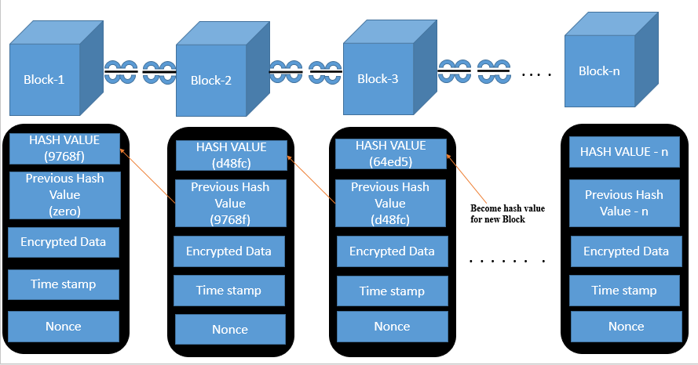

Fig 5: Block chain formation using Hash values

IV DESIGN ENGINEERING

Design engineering is the process of creating Unified Modeling Language (UML) diagrams to help communicate the design of a Model. Software design is the process of converting client requirements into a representation of the program. A design is an accurate depiction of something that will be created, Software engineering delivers quality of project through design, which is also the tool used precisely convert client requirements into the final product
So, there are so many types of systems in this design engineering, but we have used some of them which help us to understand this model in a Fairly good and straightforward manner.

- Functional Flow Diagram

Function Flow diagram indicates how all functions are coordinated each other and provide service and it has different abstraction levels. Normally, each functionality used to achieve certain operations, especially when the operation aims to accomplish several goals that need co-ordinate with each functionality. The identical Functional flow represent in Fig 6 what are the different type of activity fields like administrator and associates used to register and login, how data file stored in cloud server and associates can access the file by requesting the file and finally the data was securely transferd in the form of blocks to the end user using cyprogrpahic implementation in block chain.

The functional flow diagram of the entire Model is represented in Fig. 6, the administrator and associates used to log in and next the adminstrator uploads the data if required, and the uploaded data was encrypted and stored in database and same data was uploaded in cloud. If associates need that particualar data they can send the request for that particular data once adminstrator accept that request then by using cryptography the data was converted into the form of blocks and data was send securly to the associates and that data file can accessed by using the secure key.

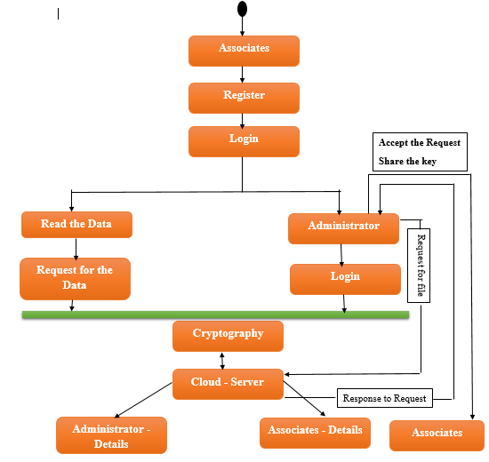

Fig 6. Functional Flow Diagram

- Data Structured Flow

Data Structured Flow diagram are visual representations, how data moves through an enterprise information system. It can be used to show the entire process how data is transferred from the starting (i.e from data uploading) till data stored in any local database or cloud.
In our model Fig 7, the main motive is store the data in the encrypted format and to transfer that stored data securely to the end user, data is stored in the local database as well as the cloud. After viewing the files by the associates they will send a request to admin for accessing the files later the admin will be reviewing the associates request,either accepting or rejecting of request is been done.Only after accepting the request,user will get an decrypted file that is been uploaded by admin to the cloud server with a access key . In a secured format with the help of the block from the cloud. The protected file can be used after key is entered. users can access the data and use it accordingly. Every file that has been uploaded will have a hash value and even the request by user and response by admin has a hash value that has been created using cryptography.
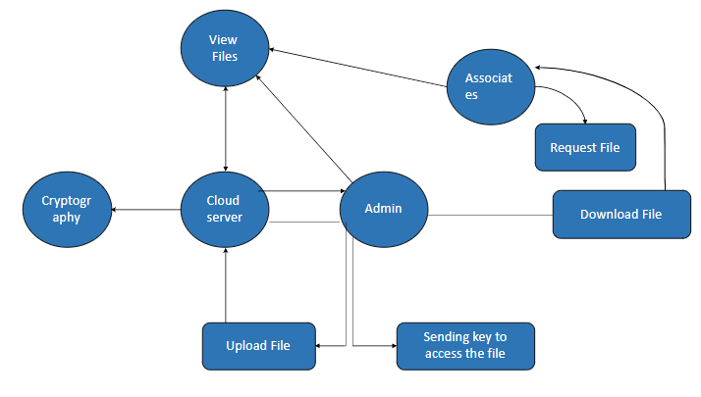

Fig 7. Data Process of our Model.

C. Instance Diagram of Model

An object diagram shows the relationship between the classes in a system and the objects that are instances of those classes. This diagram can be helpful when explaining a system's parts or when modeling recursive relationships.
This Fig. 8 represent the depicts of the different object in the proposed model there multiple classes and each have the multiple objects like administrator and associates have different number of object like there are individual object are created for individual administrator and associate so there are multiple objects for the administrator and associates. Each associate object can send the file request and administrator object related to associate object can accept the file request each administrator object have the access to the cloud the files they are stored to cloud and the requested file was send to the associate object form the cloud once the request was accepted by that particular file administrator object.
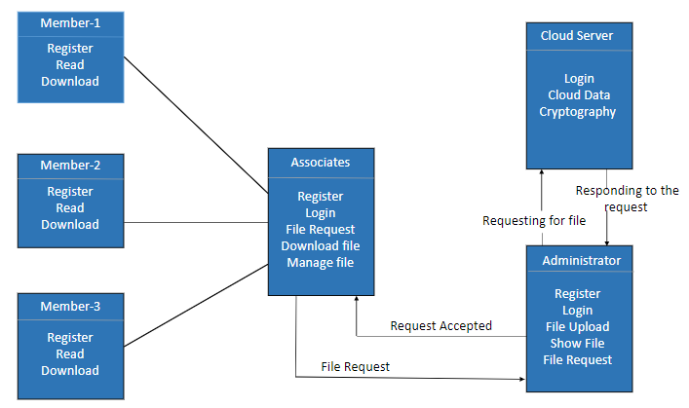

Fig 8. Multiple Users & Admins operation/procedure.

Results and Discussion
The system was successfully tested for all the CIA properties. So, as we can say that data will be more secured between end-to-end user when we are using the CIA properties in transaction of the data, we mainly proven how the CIA properties are implemented in our Model.

Fig 9 represents the data that administrator needs to communicate to the associates and the administrator can upload any type of file and uploaded file can also be viewed by administrator. Fig 10 represents associates can be able to view the data that was uploaded by the administrator and if file was required then request must be raised by the associates for that particular data and Fig 11 represent Administrator accept the file request that was raised by the associates so the associates can access that particular file. So, to access that file we use the implementation of block chain using cryptography mainly cryptography is about CIA properties.
CIA means confidentiality, integrity, and availability. Fig 12 is about the confidentiality when we want to relate how the confidentiality is implemented in our model it relates to how the key is send to the associates who are requesting for the file, and they only can view the key and by the help of that key they can be able to access the data file. The key was sent only to the specific users and not to any other users to access that file, so we can say that the key was sent very confidentially to the end user. No one else can access the data file directly without that key; only the person who can request that file can access the file with the key.
And in Fig 10 it was mentioned how the request was sent by the associates to access the file and Fig 11 represents administrator accept the file request and key was send to the associates who kept the request for the file.

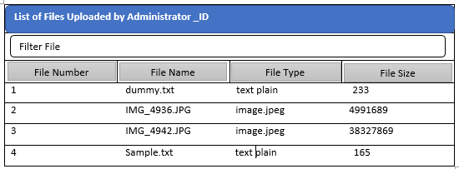

Fig 9. Administrator transmits the Data.

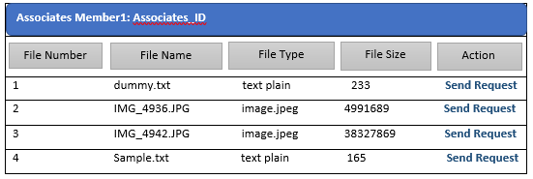

Fig 10. Associates solicit for data.
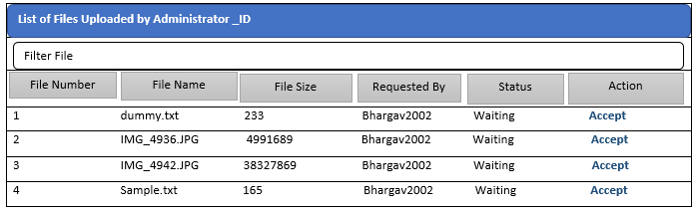
Fig 11. Administrator authorizing the data.

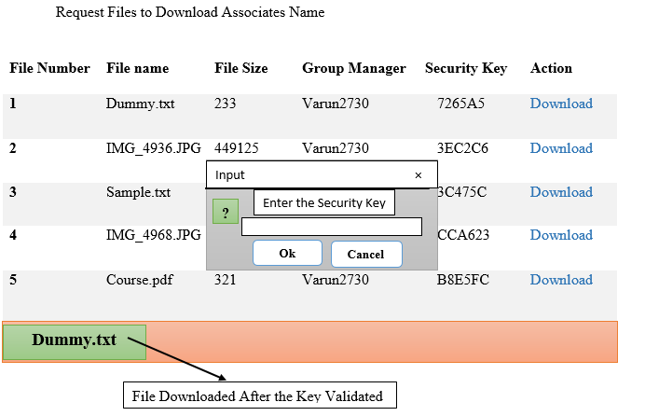
Fig 12. Associates Accessing data using Secert key.

Next is about the integrity Fig 13 that represents how securely that data was sent to the end user so here we use the implementation of the cryptography. So once the request for the file is sent to the administrator and accepts the file request, after accepting the cryptographic play the major role like it used to encrypt the data and that encrypted data was divided into the blocks format so for each block we have its own hash-values and form like a chain. And these blocks are connected to each other with the help of the “previous hash-value” and “new hash-value” so that help block to keep interlink each other. In this hash values used to provide the more security to the data as well as the used to interlink the block with the help of the hash values only. Therefore, Fig 15 if a third-party attempts to alter or manipulate the data, the hash value will change automatically, creating a new hash value and replacing the old one in the block so that the end user will be aware of the change. This will prevent the data from being altered by a third party while it is being transferred. In this we are proving the integrity how securely that data was transferred to the associates.

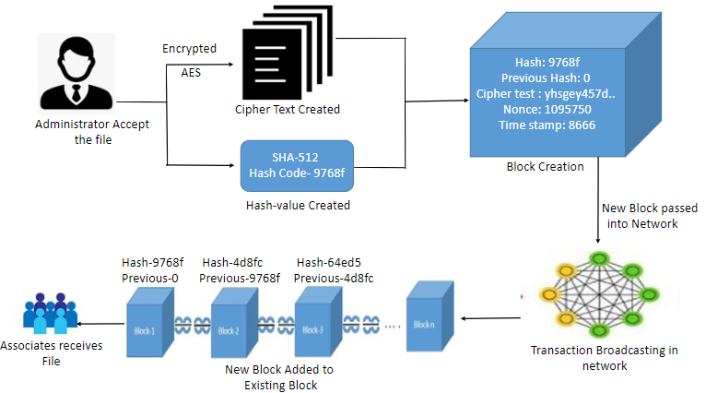

Fig 13. Interlinling of blocks using hash values.

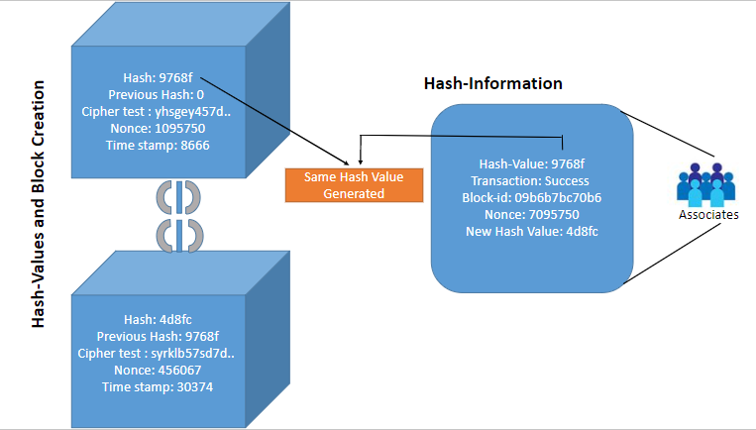

Fig 14. Identical Hash-Values at initial &final

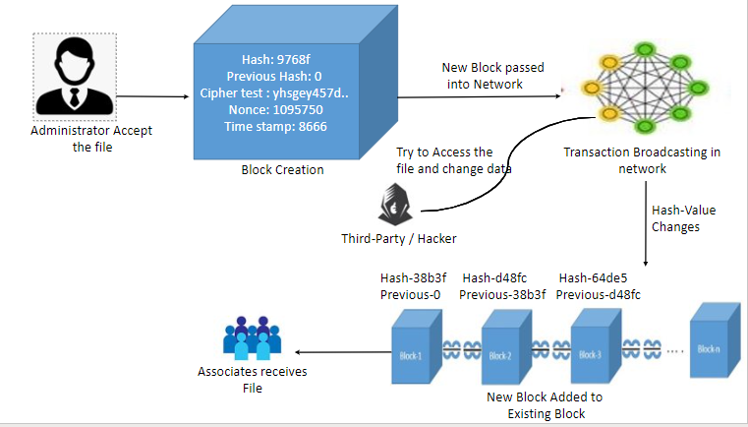

Fig 15. Non-Identical hash-values,If data is altered.

And last was about the availability Fig 16 so in this we provide that data make available to everyone so based on the user request they can be able to request for the data and can be able to access the data. When data was changed by any user using this application, it changed the data only for them and the remaining users used to have the same data as at the beginning, which helped those who had manipulated the data. In real-world applications, only administrators and associates can have the option to change the data. But as in this implantation mode we are not able to have any option to the associates to upload the file and manipulate the data by the associates, so we have just option to show what are the data that are available to the associates. The data files that are associates can see they can access only that particular file.

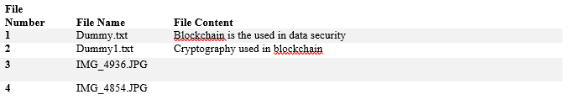
Fig 16. Accessing of data by associates.

In this model, We create building blocks for secure network coding, where the edges are vulnerable to packet erasures and Eve and the authorised network nodes have access to public feedback on the channel status. If our channels contain problems, we must first use a channel code to fix them, and then we must implement security on top of the resultant error-free network. The underlying network channels are error –free because the secure network coding. We demonstrate that, compared to the option of separate channel-error-correction followed by secure network coding, we may attain secrecy rates that are, in certain situations, several times greater by utilising erasures and feedback.

Creating test cases for unit testing assures that the fundamental programming logic is sound and that inputs from the programmer lead to valid outputs. . Verifying the internal code flow and every decision branch is crucial. It involves testing each individual piece of software that makes up the programme. Prior to integration, it carried out after every single unit is finished. It is an invasive structural test that requires knowledge of its construction. Unit tests evaluate a given configuration of a system, application, or business process and conduct fundamental tests at the component level. Unit tests ensure that every separate business process route follows closely to the given criteria and has well-defined inputs and outputs.

Moreover, functional testing contributes to systematic demonstrations that the tested functionalities are available in accordance with the business and technical requirements as well as the system specifications.

- Once the destination node received the packets, then only the references will received by the sender node.
- When the route request is needed then only the route add operation is done
- Updation of node information take place automatically in the cache.

VI. CONCLUSION

According to Research and literature, there are certain limitations in storing of data. Thus, cloud storage used to improve the data security. This paper gives the detail information about how the data was securely and efficiently stored in the cloud. Data security provided through cloud storage that uses cryptography, using this model we implemented the cryptography for the data security. The system concept implemented using efficient, quick, and highly secure algorithms that provide data stored in databases and the cloud with the highest level of protection. The proposed design make the system more secured and robust from various security assaults carried out by un-authorised users, try to tamper or steal the information.

Blockchain, a spectacular new technology, has appealing qualities with regard to data integrity among other things. In order to decrease threats to information security, national security or for other reasons, it is more crucial to protect the geographic data that is kept on the public cloud. Various cryptographic hash values guard against data tampering, whether intentional or inadvertent. Controlling and blocking any unwanted access to data stored in the cloud has now become a crucial security concern. Although encrypted email appears to be a workable option for security, it will significantly restrict their ability to operate.

VII. FUTURE ENHANCEMENT

In the future, we intend do Research and fundamentals of security enhancement utilising several blockchain technologies, including Ethereum, Private Blockchains, and Hybrid Blockchains. This will help to implement and enhance future-based security for data. As there are lot of cryptographic computer cost when we use all the algorithms so there are multiple hardware industries which are been working on the microarchitecture and innovative software optimization method which can reduce there will be less use of the Advance Encryption Standard (AES) algorithms and uses the FIPS algorithms. And there are so many cryptographic ciphers which are developed to have better data security in communication.

VIII. REFERENCES

[1] Kshitij Dhyani, Jahnavi Mishra, Subhra Paladhi &amp; I. Sumaiya Thaseen, “A Blockchain-Based Document Verification System for Employers”, IFIP International Conference 2022.

[2] LanxiangChen QingxiaoFu YiMu LingfangZeng FatemehRezaeibagha , Min-ShiangHwang, “Blockchain-based random auditor committee for integrity verification”,IEEE 2022.

[3] Jingzhe Wang; Balaji Palanisamy , “Protecting Blockchain-based Decentralized Timed release of Data from Malicious Adversaries”, IEEE Conference Publication 2022.

[4] Songwei Fan; Yue Chen, “Editable Blockchain Scheme Based on Shamir Chameleon Hash Secret Sharing”, IEEE 2022.

[5] Kwame Opuni-Boachie Obour Agyekum; Qi Xia; Emmanuel Boateng Sifah; Christian Nii Aflah Cobblah, “A Proxy Re-Encryption Approach to Secure Data Sharing in the Internet of Things Based on Blockchain”, IEEE Systems Journal 2022.

[6] R. Rajadevi; E.M Roopa Devi; R.S. Latha; S. Harshini; K. Ajay; M. Abinash,“Secured Storing and Sharing of Medical Records Based on Blockchain”,IEEE 2022.

[7] Sidra Malik; Volkan Dedeoglu ; Salil S. Kanhere ; Raja Jurdak, “PrivChain:Provenance and Privacy Preservation in Blockchain enabled Supply Chains”,IEEE international conference 2022.

[8] Partha Sarathi Chakraborty; Mangesh Shivaji Chandrawanshi ; Puspesh Kumar; Somanath Tripathy , “BSMFS: Blockchain assisted Secure Multi-keyword Fuzzy Search over Encrypted Data”, IEEE Xplore 2022.

[9] Ruizhong Du; Caixia Ma; Mingyue Li, “Privacy-Preserving Searchable Encryption Scheme Based on Public and Private Blockchains”,TUP journal 2022.

[10] Yong Wang; Aiqing Zhang ; Peiyun Zhang ; Youyang Qu; Shui Yu , “Security-Aware and Privacy-Preserving Personal Health Record Sharing Using Consortium Blockchain”, IEEE Xplore 2022.

[11] Justin S. Gazsi; Sajia Zafreen ; Gaby G. Dagher; Min Long, “VAULT: A Scalable Blockchain-Based Protocol for Secure Data Access and Collaboration”, IEEE 2021.

[12] S. Uthayashangar; T. Dhanya; S. Dharshini; R. Gayathri, “Decentralized Blockchain Based System for Secure Data Storage in Cloud”, IEEE 2021.

[13] Vardhini B; Shreyas N Dass ; Sahana R ; R. Chinnaiyan, “A Blockchain based Electronic Medical Health Records Framework using Smart Contracts”, IEEE 2021.

[14] Fujing Huang, “Rural E-commerce Investment and Financing Model Based on Blockchain and Data Mining”, IEEE 2021.

[15] Yang Xu; Ju Ren; Yan Zhang; Cheng Zhang; Bo Shen; Yaoxue Zhang “ Blockchain Empowered Arbitrable Data Auditing Scheme for Network Storage as a Service”, IEEE 2020

[16] Tariqul Islam; Kiho Lim; D. Manivannan, “ Blending Convergent Encryption and Access Control Scheme for Achieving A Secure and Storage Efficient Cloud”, IEEE 2020.

[17] Sujatha.R , Dr.Ramakrishnan.M,” Optimal ECC Based Hybrid Signcryption for MANET Security”, 2016

[18] Sujatha, Ramakrishnan and Duraipandian, “Optimal Adaptive Genetic Algorithm Based Hybrid Signcryption Algorithm for Information Security, Computer Modelling and Engineering Science”, 2015

